TEXT MINING AND NATURAL LANGUAGE PROCESSING

What is NLP? It is a branch of AI dealing with human language.
Intelligence compromises capacities for:
- Abstract thought
- Understanding
- Communication…
There is a difference between data processing and language processing:
- Data are for instance bytes and lines.
- Linguistic objects are for instance words.

Some problems and facts about linguistic useful for natural language processing

Some properties of language:
- Treno (it has meaning in italian)
- Trone (no mean but it is a legal sequence in italian)
- Nrtoe (it is a legal sound; however, it is not legal to form an Italian word, also it has no meaning)
We have sounds that are legal for a language and sequences that are legal for a specific language.
- Marco mangia una mela (it is a legal sequence)
- *Mangia mela Marco una (it is not a legal sequence)
- Nessun bambino ha mangiato una mela (it is a legal sequence)
- *Un bambino ha mangiato nessuna mela (it is not possibly in italian, but it possible in english)
Properties vary language by language.
- Cosa ha mangiato il bambino?
- *Cosa il bambino ha mangiato?

- Il mago applaude la puffetta sullo sgabello (it is ambiguous because it could represent different things 🡪 images to describe the different meanings)
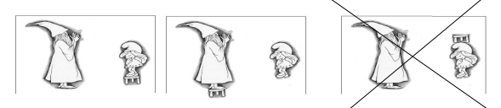

There are rules for combination of sounds that are called phonotactic rules: the default order in Italian is subject, verb, object (SVO). In other languages, the order is subject, object, verb (SOV)

What does linguistic study?
Linguistic studies the characteristics of human language through its manifestation, that is, the study of languages.
Language a single word in English that corresponds to two translations in Italian:
- Lingua = system of signs used by a certain human community to communicate (Italian, French…)
- Linguaggio = set of properties common to all sign system used by human communities

Human Language Features
There are common features that are shared by all human languages. Language transmits information and makes things happen. But it is also something more.
Features from Charles Hockett:
- Arbitrariness (Donna vs Woman, Acqua vs Water) 🡪 refer to the same entity
- Discreteness (Leo + ama + Eva = Leo ama Eva)
- Structure (Leo ama Eva vs Eva ama Leo)
- Creativity (Leo ama una formica rossa)
- Recursivity (Lo zio del fratello del nonno della mamma) 🡪 I could go on how much I want
- Semanticity
- Displacement
- Metalanguage

DISCRETENESS
It refers to finite set of definite elements and a finite set of combinatorial rules with which to construct a potentially infinite set of expressions. Example: r, o, a, m, l, I, s, p, n, e
- L+e+o = LEO, l+i+s+a = LISA
Sounds are discrete but we can obtain an infinite number of words.
The same is for sentences.
- Leo piange per AMOR
- Leo piange per ROMA
STRUCTURE 🡪 GRAMMAR (there is a structure that is given by rules)
- *Lisa Leo ama (it is not correct)

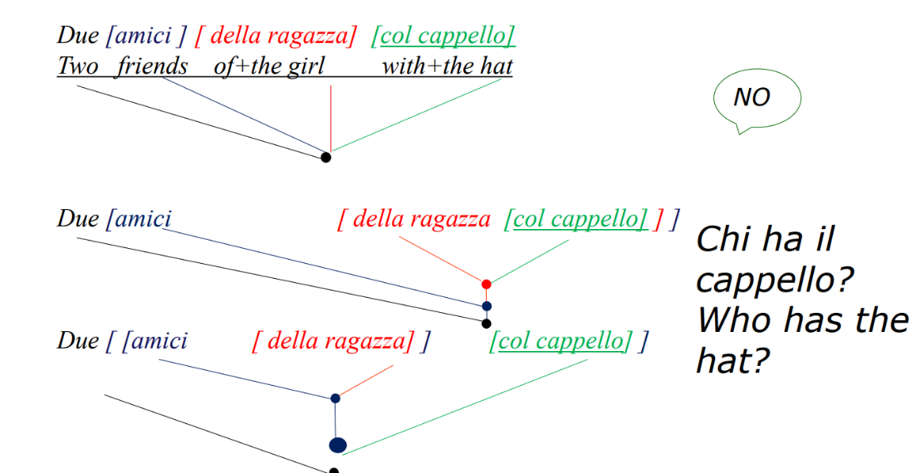
STRUCTURE 🡪 HIERARCHY:

- Due amici della ragazza col cappello (here there is an ambiguity: chi ha il cappello? The girl OR the friends?)
- Words are hierarchically and you can attach hierarchy at different levels.

CREATIVITY
You can invent sentences you never hear but you can figure out something about.

RECURSIVITY: ex: Il bastone
che picchiò il cane
che morse il gatto

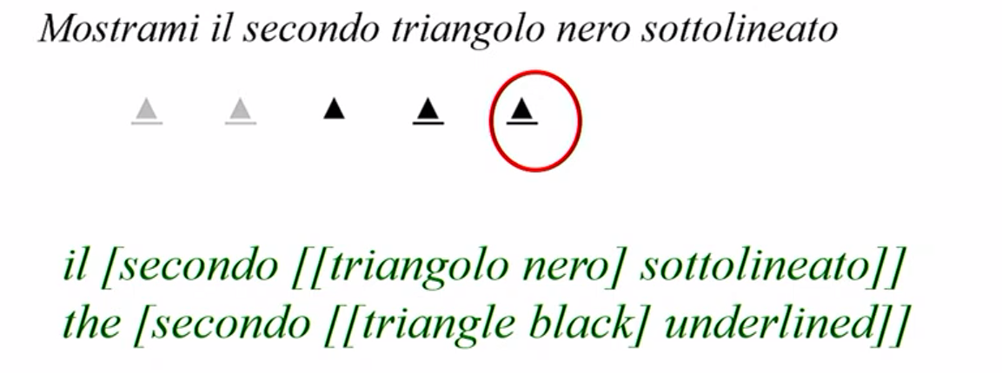
The second in this case is the last piece that we put together.

So, the language has a hierarchal and not flat (point where everything comes) structure and this structure is the result of recursive rules.
A recursive rule is a rule that can be applied to the result of itself (the rule of arithmetic +1 is a recursive rule)

Case of ambiguity:
- La [ [seconda] [ruota rossa] ] CORRECT
- La [ [seconda ruota] [rossa] ] NOT CORRECT
We apply the rule of modification by an adjective.
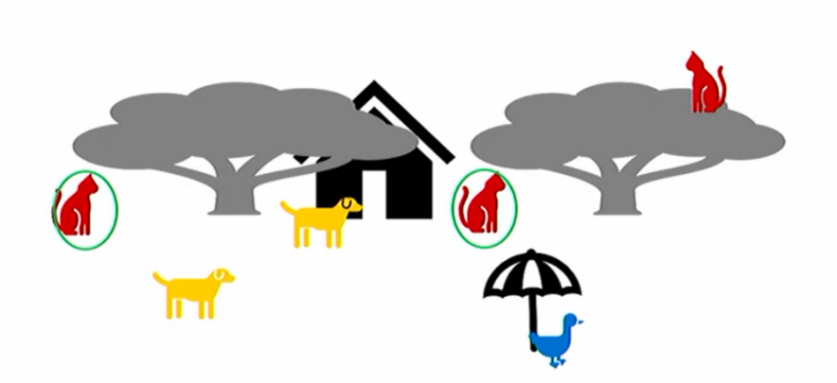
Look at the cat under the tree near the house:
Which cat? There are two possible cats.
The sentence is not just a sequence of words, depends on how we put the words together.
There are two interpretations (depends on how we construct the hierarchy):
1 Interpretation:
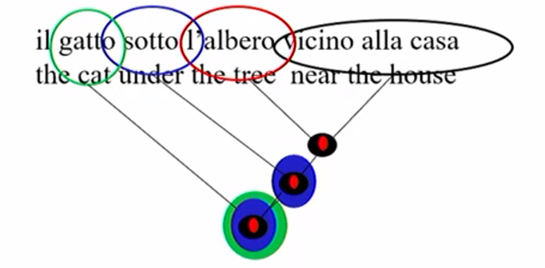
- Firstly, we take [Near the house] and it could refer to the tree, dog or the cat
- Then we take [the tree] that we can have two different
- Then we combine the [the tree near the house] and we have only one option
- Now we add [under] and it could refer to different animals but once I attach under the tree near the house could be this dog
- Finally, we attach [the cat] and we arrive to the final interpretation.

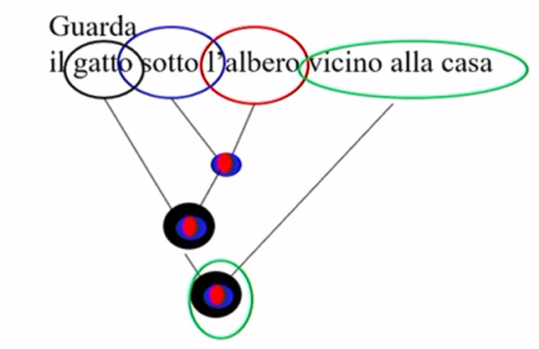
2 Interpretation:
- Firstly, we take [the tree]
- Then we take [under] and we put together with [the tree]
- Now we have the [the cat] and we put together with [under the tree]
- But now we can have two different cats: we choose the cat [near the house]

We end up with two representations.
- Near the house can modify the tree
- Near the house can modify the house

What does it mean to be competent in a language?
Consider the following sentences:
- Il poliziotto che inseguono i ladri / the policeman that thieves chase
- Il poliziotto che insegue i ladri / the policeman that chases the thieves
In Italian we can put the subject after the verb, in English we can’t because the meaning of the sentence would change. (Ha telefonato uno strano tipo oggi)
- Il poliziotto insegue i ladri? / Does the policeman chase the thieves?
In this case, in Italian the questions are made by the role of intonation.
Language is more than a sequence of words that stand for objects and relationships between objects. The functional elements are the auxiliary, articles.

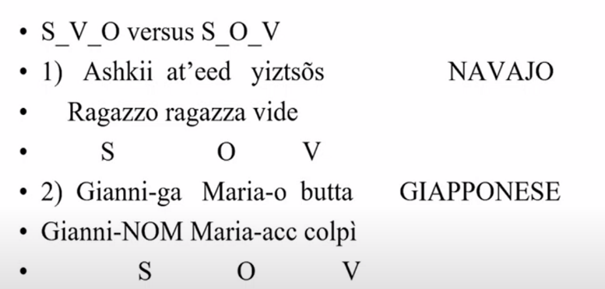
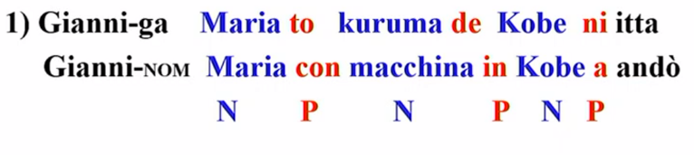
Structure, Order

There are universal principles in languages (a certain consistency in the languages):
- S V O 🡪 P N predicato: io sono tito
- S O V 🡪 N P

English, Italian, French
We have certain similarities:
- Gianni ha telefonato ITA
- Gianni has called ENG
- Gianni a appele FRA
And certain differences:
- Ho telefonato ITA (in Italian we know what is the subject with only the verb)
- Have called ENG (in English and French we have to specify the subject)
- Ai appele FRA

- (pro) Piove ITA (in Italian we can/must drop subjects)
- It is raining ENG (in French and English we have to express the subject)
- Il pleut FRA

Why it is relevant to know something about linguistic for Natural Language Processing?
Because knowing the linguistic structure can allow to create better systems of machine learning, annotation, machine translation. Moreover, understanding errors is useful to increase the knowledge of the system.
What we know?
- Language is for communication, but it is not communication.
- There are distinctive properties of language aka language has structure.
- There are similarities and difference between languages.
- Why it is useful to know these rules for NLP?

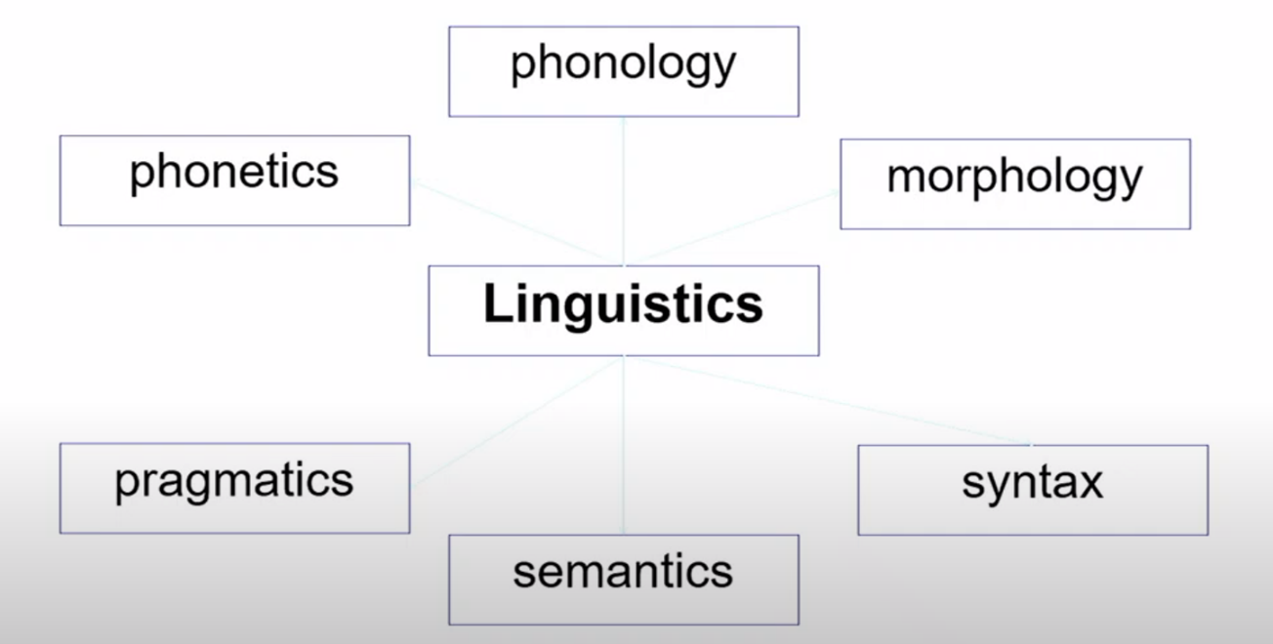

From sound to messages
Firstly, we have to start from Phonetics.
It studies the physical characteristics of linguistic sounds and how they are produced. We can study the sound in 3 ways:
- Articulatory: how the vocal cords are organized to produce a sound
- Acoustic: study the physical properties of linguistic sounds
- Perceptual: study how language sounds are perceived

Phonology studies the mental representation of linguistic sounds.
For instance, if we take [pino-fino-tino] what changes is only the first sound (called phoneme) that distinguishes the whole meaning of the words, but it does not have its own meaning. For instance, [Face-Case] where F, C are phonemes.
When we look for phoneme we don’t have to look for orthography but only for the sounds. Phonemes are in our minds (in Japanese, r-l are not distinguished because they are not distinctive and these sounds don’t play a role, instead in Italian they play an important role because our mind distinguish it).
Phonology studies systematic knowledge that tell the speaker how to merge such sounds and pronounce a word (so the intonation).
Moreover, it indicates which sound sequences are permissible in Italian ([sedia-bedia-bsedia] the first exist, the second is permissible but the third not).
Phonology and Phonetics are relevant when you do speak processing.

Sounds and Writing
The sounds of language are physical events and are evanescent, transient. They have no persistence in time. Writing makes language productions persistent over time.
The invention of writing is recent. Before 3000 Bc in Mesopotamia and Egypt, 1300 Bc in China, 600 Bc in Mexico.
There are different writing systems:
- Logographs (ideographic): signs correspond to word or more correctly morphemes, but often words have only (Mandarin).
- Syllabics: elementary signs correspond to syllables (Hindi)
- Alphabets: the signs (grapheme) correspond to phonemes (Semitic, Greek, Latin, Italian) and we put together these signs to form words.

Mandarin characters: how to tokenize?
Tokenization = divide a text into individual components (words), inserting spaces, separating punctuation marks. But how do we find words?
- In Italian, English is easy because text contains spaces between words, even though…
1 or 2 tokens? 🡪 Kim did not leave vs Kim didn’t leave.
- In Mandarin tokenization is more difficult. There are classifiers (something like an article but they have a semantic meaning, we can have classifiers for humans, animals, shapes…)

What we called a WORD is something very arbitrary.
- Sabwaye (1 word in Lakhota) the translation is [I made it black].
- Teninonhishsaks (1 word in Mohawk) the translation is [Let’s go look for the house].
We have to understand the meaning and do the translation.

Morphology studies the process of word formation and their internal structure.
You can have words that have something in common. We can have other words that have different meanings or add something to the meaning.
- Pagare V Lavare V
- Pagabile A Lavabile A
- Pagavo V Lavavo V
- Paga(la) N Lava(la) N

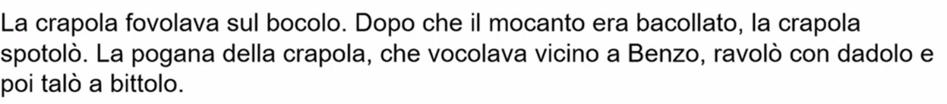
Morphosyntax is the difference between a sentence and a bag of words. Example of [Carrol, Alice in the wonderland].

A bag of words is a set of words that do not have a structure but in this case (example) this set of words have a structure that we can recognize (because we are Italian) 🡪 morphosyntax cares about the modification of words that have an influence on the combinatorial potential at the level of the sentence: e.g., sings you can combine only with 3rd person subject. If you know the linguistic rules of the language (morphology) you are able to discriminate the syntactic components of the language. (ex: favolava must be a verb and crapola is its subject)

Syntax cares about the orders of words and how you combine things that are far from each other. It studies the organisation of words in sentences and how words are put together in groups called constituents. Example:
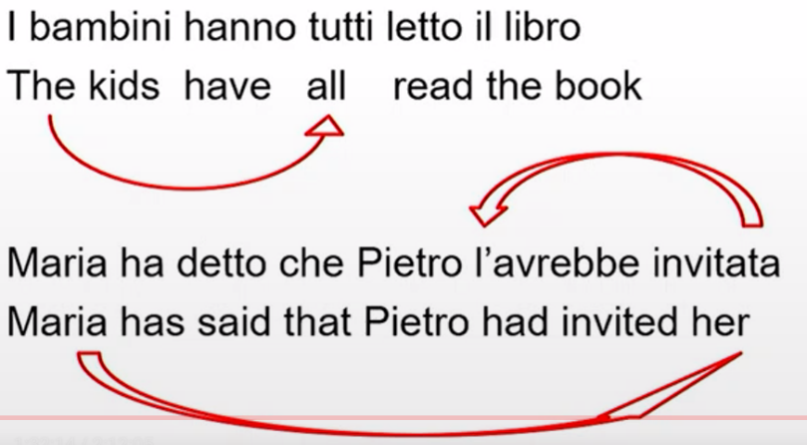
- In the first sentence, [The kids have all] must stay together.
- In the second sentence, [Maria has said.... her] we have to specify the pronoun, instead in Italian we made an elision and we put together [l’avrebbe invitata] 🡪 there is a dependency

Semantics cares about meaning.
Example: [I saw the French president on TV] 🡪 here the name French president is used to refer (the referent in this case has changed over the year)
It cares also about relation between words:
- Homonymy (porta as verb and noun)
- Synonymy (catastrofe, disastro)
- Antonymy (vivo-morto)
Sentences semantics cares about true/false and the relation between sentences:
- Entailment: if 1 is true 2 also is true (1. Gianni bought a greyhound 🡪 2. Gianni bought a dog)
- Presuppositio: The French President visited Italy (if the France does not have a president, then the sentence it does not have sense)

Pragmatics cares about how speaker integrate meaning and context for communication purpose or how speakers use language. It cares also about informativeness of sentences.
Example: That is the door, with this sentence
- I can describe the door in normal contexts.
- If I am angry I can mean that you should go out
Speech acts: The dog entered from the window that is a question or description (depends on the context) and refers to the act of speeching, promising.
Implicature: In my aquarium some fish have spots is true, but if the in the aquarium all the fishes have the spot then it should be more accurate using all.

